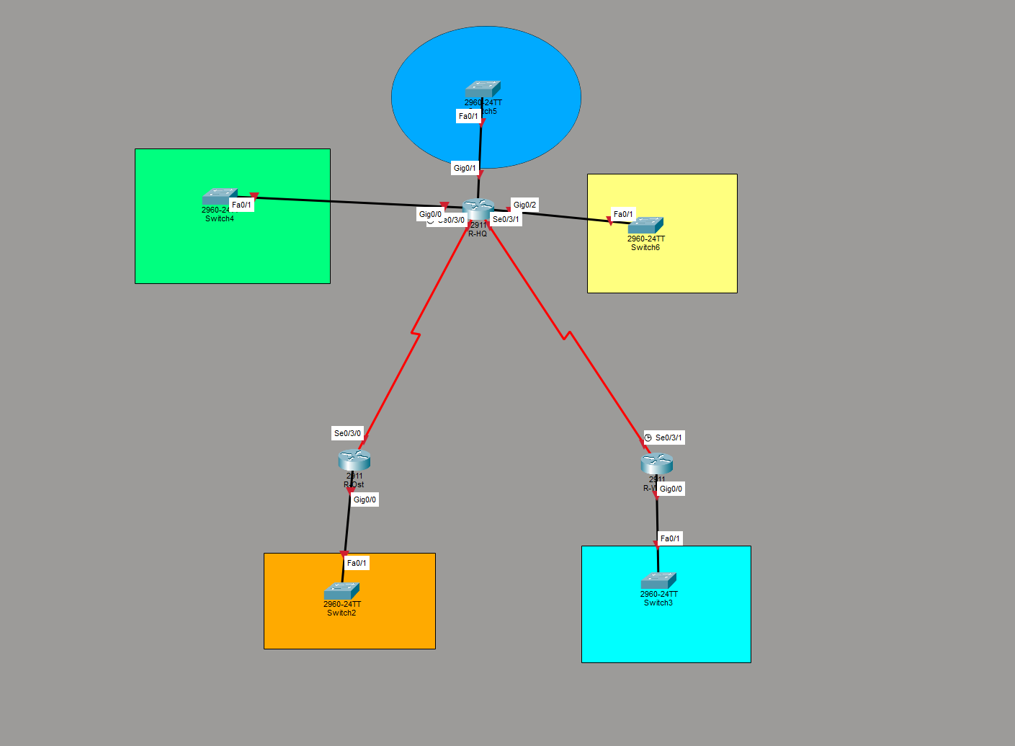
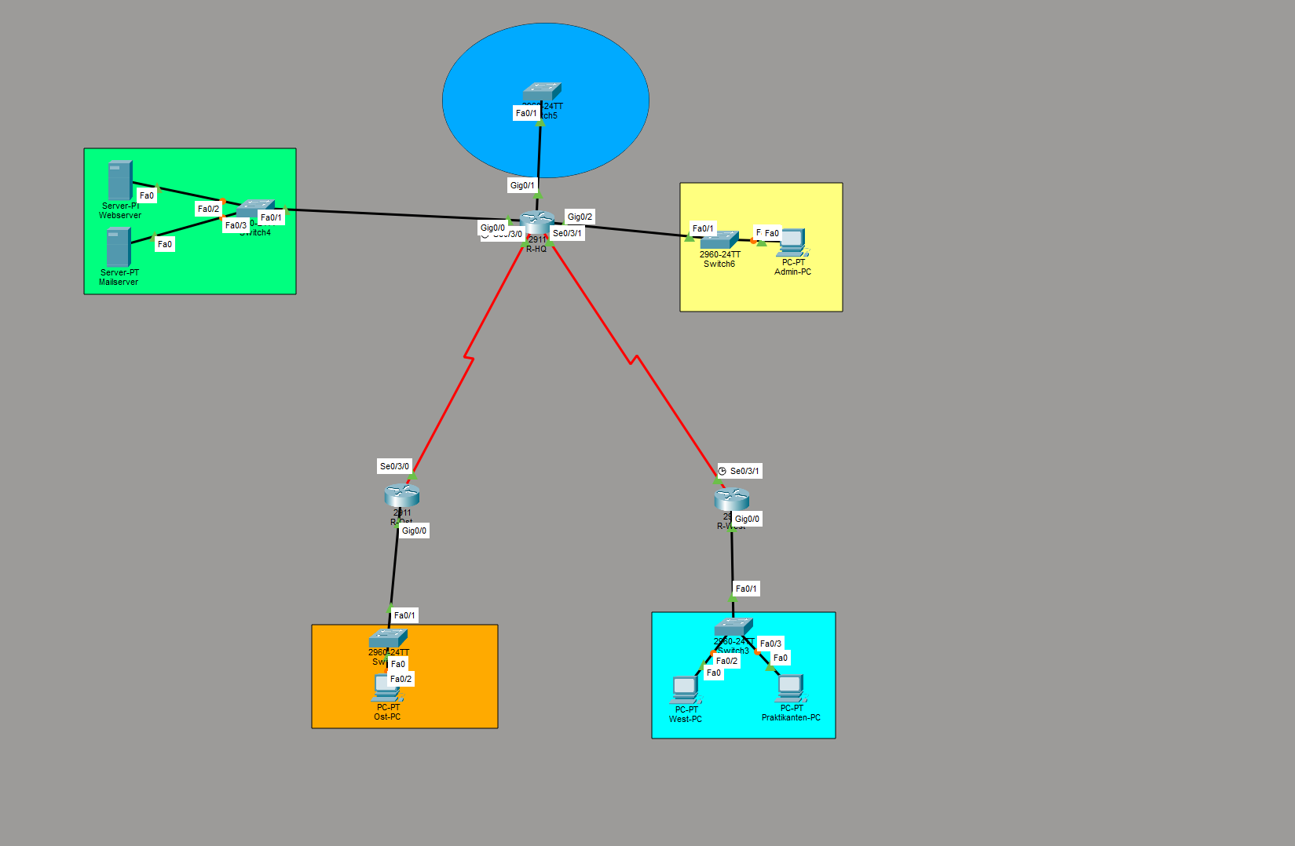
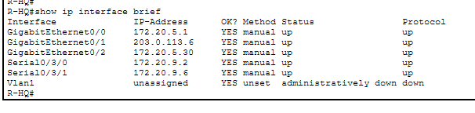
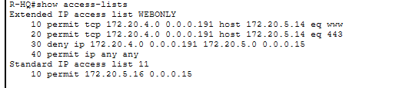
R-HQ#
R-HQ#show ip interface
GigabitEthernet0/0 is up, line protocol is up (connected)
Internet address is 172.20.5.1/28
Broadcast address is 255.255.255.255
Address determined by setup command
MTU is 1500 bytes
Helper address is not set
Directed broadcast forwarding is disabled
Outgoing access list is WEBONLY
Inbound access list is not set
Proxy ARP is enabled
Security level is default
Split horizon is enabled
ICMP redirects are always sent
ICMP unreachables are always sent
ICMP mask replies are never sent
IP fast switching is disabled
IP fast switching on the same interface is disabled
IP Flow switching is disabled
IP Fast switching turbo vector
IP multicast fast switching is disabled
IP multicast distributed fast switching is disabled
Router Discovery is disabled
IP output packet accounting is disabled
IP access violation accounting is disabled
TCP/IP header compression is disabled
RTP/IP header compression is disabled
Probe proxy name replies are disabled
Policy routing is disabled
Network address translation is disabled
BGP Policy Mapping is disabled
Input features: MCI Check
WCCP Redirect outbound is disabled
WCCP Redirect inbound is disabled
WCCP Redirect exclude is disabled
GigabitEthernet0/1 is up, line protocol is up (connected)
Internet address is 203.0.113.6/29
Broadcast address is 255.255.255.255
Address determined by setup command
MTU is 1500 bytes
Helper address is not set
Directed broadcast forwarding is disabled
Outgoing access list is not set
Inbound access list is not set
Proxy ARP is enabled
Security level is default
Split horizon is enabled
ICMP redirects are always sent
ICMP unreachables are always sent
ICMP mask replies are never sent
IP fast switching is disabled
IP fast switching on the same interface is disabled
IP Flow switching is disabled
IP Fast switching turbo vector
IP multicast fast switching is disabled
IP multicast distributed fast switching is disabled
Router Discovery is disabled
IP output packet accounting is disabled
IP access violation accounting is disabled
TCP/IP header compression is disabled
RTP/IP header compression is disabled
Probe proxy name replies are disabled
Policy routing is disabled
Network address translation is disabled
BGP Policy Mapping is disabled
Input features: MCI Check
WCCP Redirect outbound is disabled
WCCP Redirect inbound is disabled
WCCP Redirect exclude is disabled
GigabitEthernet0/2 is up, line protocol is up (connected)
Internet address is 172.20.5.30/28
Broadcast address is 255.255.255.255
Address determined by setup command
MTU is 1500 bytes
Helper address is not set
Directed broadcast forwarding is disabled
Outgoing access list is not set
Inbound access list is not set
Proxy ARP is enabled
Security level is default
Split horizon is enabled
ICMP redirects are always sent
ICMP unreachables are always sent
ICMP mask replies are never sent
IP fast switching is disabled
IP fast switching on the same interface is disabled
IP Flow switching is disabled
IP Fast switching turbo vector
IP multicast fast switching is disabled
IP multicast distributed fast switching is disabled
Router Discovery is disabled
IP output packet accounting is disabled
IP access violation accounting is disabled
TCP/IP header compression is disabled
RTP/IP header compression is disabled
Probe proxy name replies are disabled
Policy routing is disabled
Network address translation is disabled
BGP Policy Mapping is disabled
Input features: MCI Check
WCCP Redirect outbound is disabled
WCCP Redirect inbound is disabled
WCCP Redirect exclude is disabled
Serial0/3/0 is up, line protocol is up (connected)
Internet address is 172.20.9.2/30
Broadcast address is 255.255.255.255
Address determined by setup command
MTU is 1500
Helper address is not set
Directed broadcast forwarding is disabled
Outgoing access list is not set
Inbound access list is not set
Proxy ARP is enabled
Security level is default
Split horizon is enabled
ICMP redirects are always sent
ICMP unreachables are always sent
ICMP mask replies are never sent
IP fast switching is disabled
IP fast switching on the same interface is disabled
IP Flow switching is disabled
IP Fast switching turbo vector
IP multicast fast switching is disabled
IP multicast distributed fast switching is disabled
Router Discovery is disabled
IP output packet accounting is disabled
IP access violation accounting is disabled
TCP/IP header compression is disabled
RTP/IP header compression is disabled
Probe proxy name replies are disabled
Policy routing is disabled
Network address translation is disabled
WCCP Redirect outbound is disabled
WCCP Redirect exclude is disabled
BGP Policy Mapping is disabled
Serial0/3/1 is up, line protocol is up (connected)
Internet address is 172.20.9.6/30
Broadcast address is 255.255.255.255
Address determined by setup command
MTU is 1500
Helper address is not set
Directed broadcast forwarding is disabled
Outgoing access list is not set
Inbound access list is not set
Proxy ARP is enabled
Security level is default
Split horizon is enabled
ICMP redirects are always sent
ICMP unreachables are always sent
ICMP mask replies are never sent
IP fast switching is disabled
IP fast switching on the same interface is disabled
IP Flow switching is disabled
IP Fast switching turbo vector
IP multicast fast switching is disabled
IP multicast distributed fast switching is disabled
Router Discovery is disabled
IP output packet accounting is disabled
IP access violation accounting is disabled
TCP/IP header compression is disabled
RTP/IP header compression is disabled
Probe proxy name replies are disabled
Policy routing is disabled
Network address translation is disabled
WCCP Redirect outbound is disabled
WCCP Redirect exclude is disabled
BGP Policy Mapping is disabled
Vlan1 is administratively down, line protocol is down
Internet protocol processing disabled

R-HQ#

